***Pay Period and Wages Calculation***

|  |  |
| --- | --- |
| PayPeriod | |
| PeriodID |  |
| From | DATE |
| TO | DATE |

|  |  |
| --- | --- |
| PayPeriod | |
| PeriodID | 001 |
| From | April 1st, 2016 |
| TO | April 30, 2016 |

|  |  |
| --- | --- |
| Payroll | |
| PeriodID | FK |
| WorkerID | FK |
| DaysWorked | Small integer |
| SupHours | Real |
| SupPay | Real |
| ExtraHours | Real |
| ExtraPay | real |
| Earned | real |
| Discounts | real |
| Fines | real |
| Loan | real |
| Meals | real |
| Absence | real |
| Total Deduction | real |
| NetPay | real |

***How the data is collected now :***

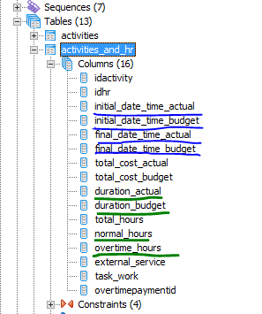

Information such as worker’s Name, Title, Identification number, Base Salary should come from HR table.

HR table would need to be altered:

Change: ***Annual Wage 🡪 Monthly (Base) Pay***

New: ***Position*** (Laborer, Accountant, Tractor Driver, Foreman, etc,)

Hourly cost to be calculate field: Base Salary / (30 days *8 hours) = ***Base Salary /240***

From Ana Layman’s example, all numbers are rounded up:

Example: Base Salary = $367.83, $367.83 /240 = $ **1.53**2625,

150% = 1.5 * 1.532625 = **2.298**9375 🡪 $ **2.30**

200% = 2* 1.532625 = **3.065**25 🡪 $ **3.07**

Questions to Ana Layman:

1. On the sample spreadsheet I see worker who has 0 work days. Is this someone who resigned but you still keep him in the system?
2. Who keeps track of number of working days of each individual? What happens for example if person hired in the middle of the month?
3. Where the information about Food Purchases comes from? What structure supports it?
4. “---“------“-----“-----“-----“ Absences? Loans? Fines? Misc. Discounts?
5. ***Absences:***

Business Rules for Absences:

Unjustified:

0.5 day - Fine equaling to 8 work hours is withheld

1 day - Fine equaling to 12 work hours is withheld

* Penalty can‘t be bigger than 10% of salary (***monthly salary***?)

***Overtime :*** Do we what to keep track of Overtime in Addition to being able to populate this data and generate the report as activities being assigned?